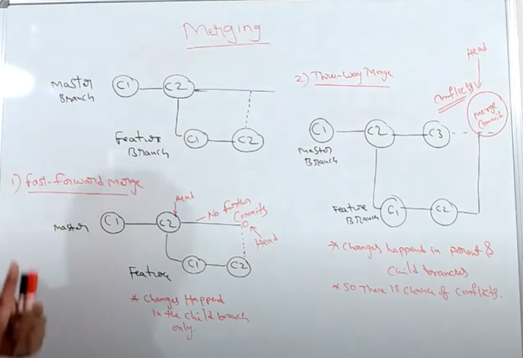**Git merging Command**

Two types of merging :-

1. Fast forward merging (FFM) : –

In, FFM the changes will happened in the child branch only. We didn’t change or commit in master branch.

We can explain FFM by the below diagram:-

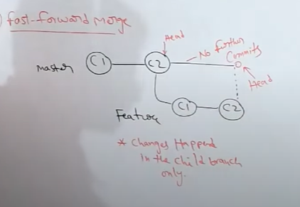

Here , We have a master branch c1,c2,…. and we create child or feature branch a1 , a2 ,….. . In FFM , we didn’t change anything or there is no further commits in master branch . But we make changes in feature or child branch and simply merge it into the master branch.

1. Three way merging (TWM):-

In, TWM the changes will happened in the master or child branch parallelly.

Here, We have master branch c1,c2,c3…. and we create child or feature branch a1, a2, a3, …... In TWM, we parallelly change in master branch or feature branch. So, there is chance of conflicts.

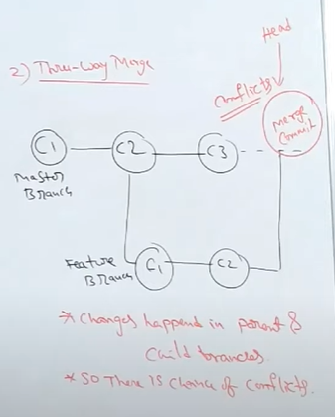

Working with merge command –

Fast Forword –

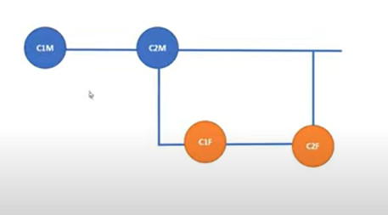

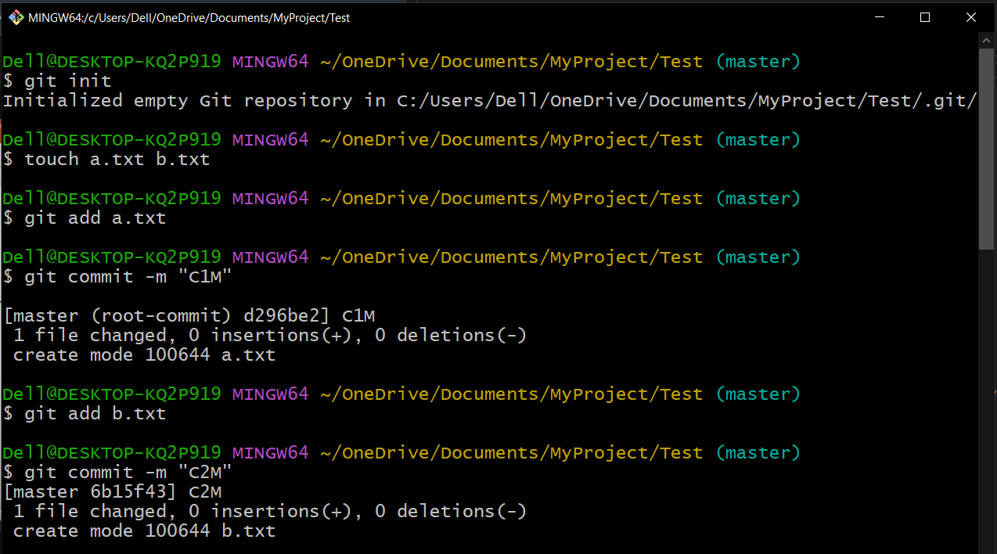

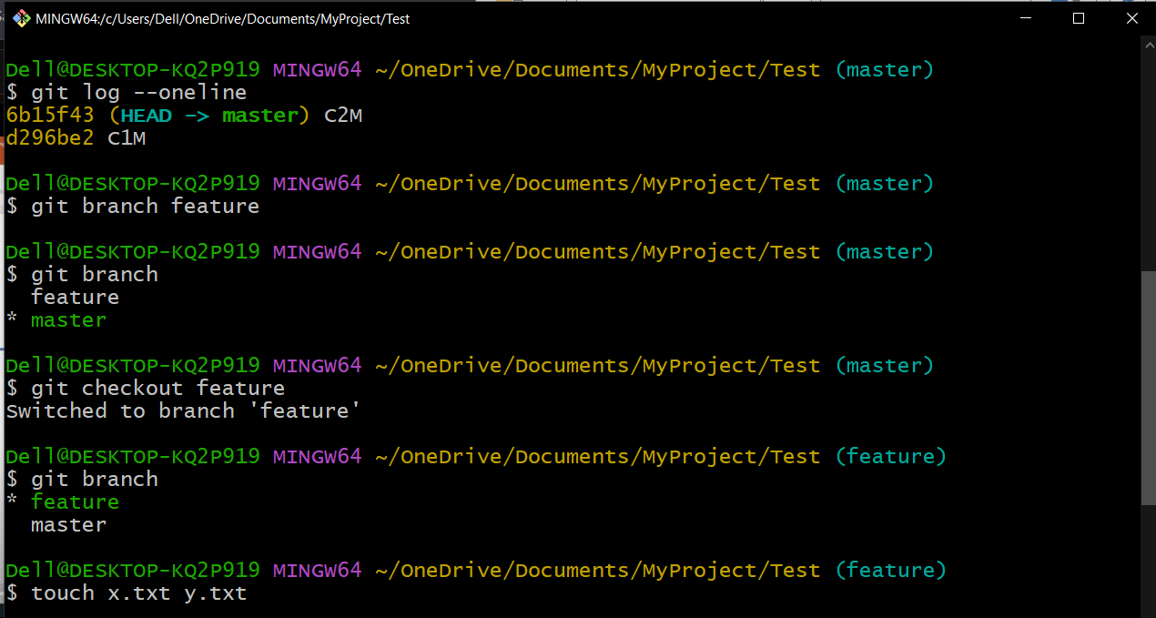

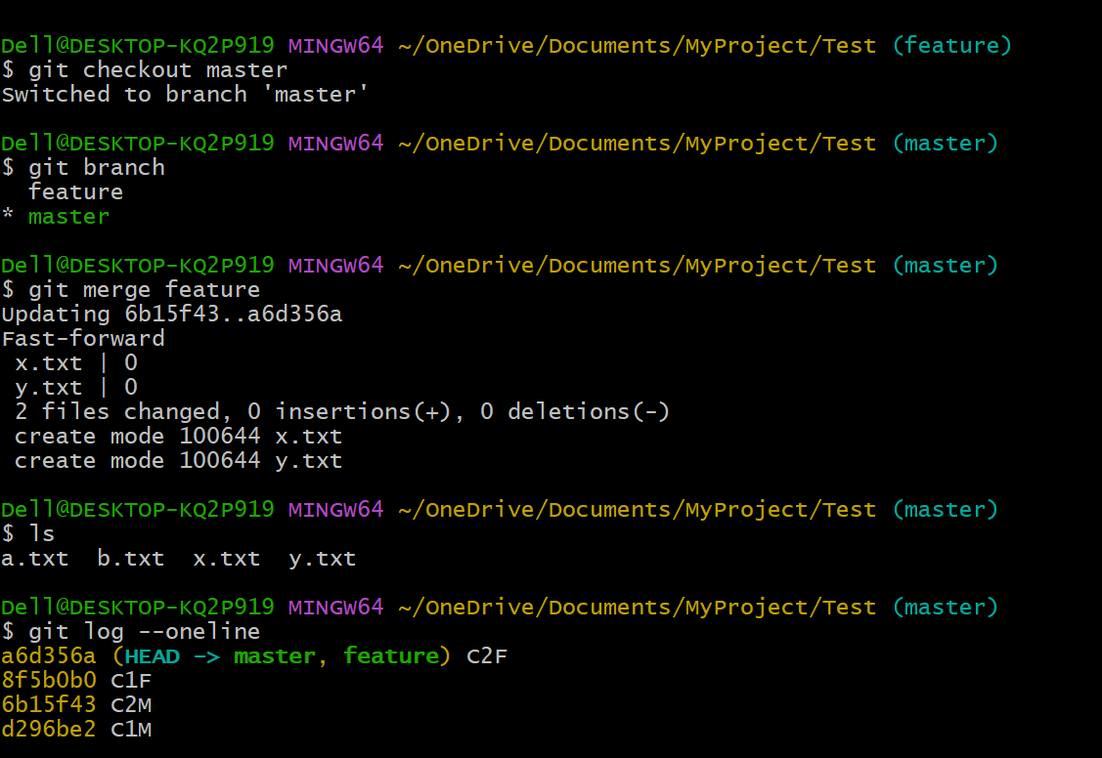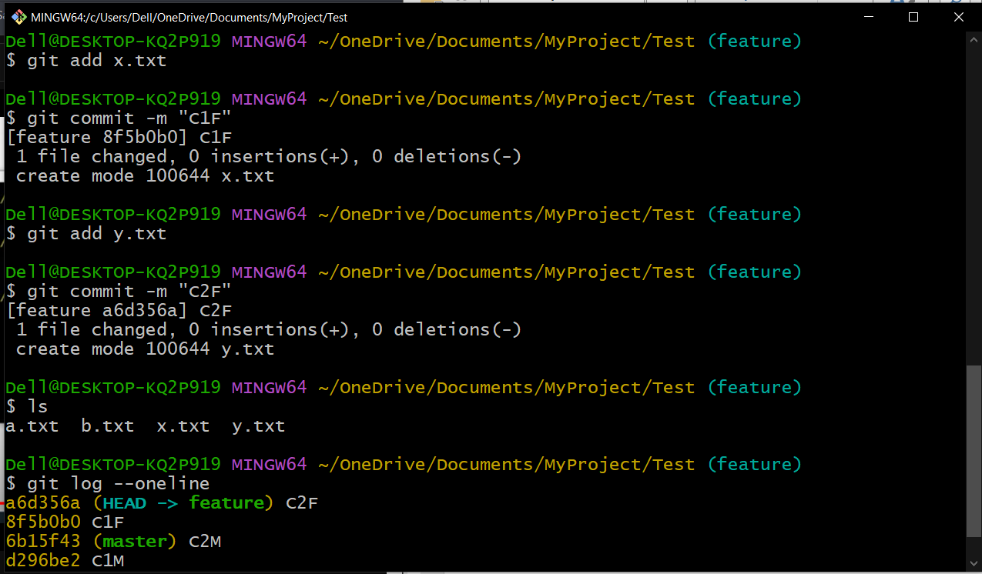

Three way merging :-

